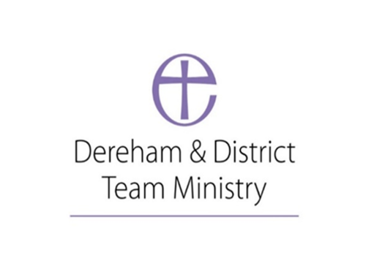
Parish of St. Nicholas Church Dereham
Risk Assessment & Management for Large events in Church
Date of first risk assessment: 11/05/2022
Time/frequency: Annual
Date to be reviewed: 11/05/2023
Trips & slips risk
What is the risk? | Who might be harmed? | What are we doing to reduce the risk? | What additional steps do we need to take? | Action by whom? | Action completed  (date) | Addition notes
South side Lantern Tower step (uneven height) | Guests visiting the Church | The step will be roped off to direct people elsewhere | none | NA | NA | NA
Steps around the Altar and lectern’s  (Narrow and uneven.) | Guests visiting the Church | A rope will be placed behind the Altar and before the Lantern Tower to restrict access | Monitor that people avoid the area when visiting | The rope will be put up by the Verger.
Generally uneven floors throughout the Church | Guests touring the Church or moving through to their seat. | A sign will be placed in the Porch warning people as they enter the Church that in common with all old buildings the flooring is uneven, and care should be taken |  | RAH to produce and laminate a sign
Heating duct grill could cause a fall | Guests in high heels catching in the grill | Warning given in introductory Health and Safety session at the beginning of the event. |  | Event host
Porch gate has a raised metal hole for securing the gates. | Guests entering the Church | Review the bolt drop can we make it deeper and still secure the gate therefore removing the risk | If this is not possible paint the bolt drop | PC and DW
Cobbles in the Porch entry can be a trip hazard and when wet a slip hazard. | Anyone entering the Church via the normal entry point | Arrange to have the Cobbles re pointed with Lime Mortar which will reduce the clip and trip risk. |  | PC to Discuss with Medieval Masonry.  SH to discuss with the company which did the work on the Belltower to establish their suitability.  PC to let the DAC know what we are proposing to do.
Spiral staircase accessing the muniments room. | Anyone climbing and accessing the rooms falling | Ensure the door at the top of the stair is always locked and that there is a rope across the bottom barring access at all times |  | NA already in place

Fire /Evacuation risks
What is the risk? | Who might be harmed? | What are we doing to reduce the risk? | What additional steps do we need to take? | Action by whom? | Action completed  (date) | Addition notes
Evacuating a large number of people in the event of a fire. | attendees | 1)A fire evacuation policy will be developed | 2)Stewards are aware of the policy and trained | - RAH using that for messy Church as a starting point  - Churchwardens to make sure Stewards are aware of what needs to be done in the event of a fire
Exiting the building in the event of a power failure | Attendees | Purchase and get wired in three exit signs for the emergency exits which are lit in the event of a power failure |  | SH to enquire from the company who inspect the fire extinguishers what they could provide.
Lit candle in the Lady Chapel | Could result a fire as left unattended to allow small candles to be lit. | The candle is stood in sand and is some distance from any other flammable material. | Be aware of risks if taking flammable material into the Lady Chapel
Is the fire extinguisher provision adequate | Could result in a fire gaining hold and risk to all | Review the advice on extinguisher numbers and consider if we should have additional water extinguishers in the vergers store or Lady Chapel |  | SH to review the provision with the company who inspect the fire extinguishers.

Catering
What is the risk? | Who might be harmed? | What are we doing to reduce the risk? | What additional steps do we need to take? | Action by whom? | Action completed  (date) | Addition notes
Allergic reaction to food provided | Guests who have significant allergies | - Have lists of ingredients available so caterers can share with guests.  - Have gluten free products available from a gluten free kitchen if possible. | 3)Have a statement on the list of announcements at the beginning making clear we cannot guarantee allergens where not present in the kitchen’s food was prepared | 1) caterers  2) catering organiser  3)head Steward or Host

Major Services and Concerts/Events
What is the risk? | Who might be harmed? | What are we doing to reduce the risk? | What additional steps do we need to take? | Action by whom? | Action completed  (date) | Addition notes
Stage creation | Those constructing the stage | The stage should only be constructed in the presence of someone who has knowledge of the process. |  | DW to construct a list of those who know how it should be done.

Toilets
What is the risk? | Who might be harmed? | What are we doing to reduce the risk? | What additional steps do we need to take? | Action by whom? | Action completed  (date) | Addition notes
No toilets in Church, guests will need to visit the Church House toilets |  | This should be part of the Pre event health and safety talk

Asbestos Register
What is the risk? | Who might be harmed? | What are we doing to reduce the risk? | What additional steps do we need to take? | Action by whom? | Action completed  (date) | Addition notes
There is no Asbestos in Church to our knowledge | NA | NA | NA

What is the risk? | Who might be harmed? | What are we doing to reduce the risk? | What additional steps do we need to take? | Action by whom? | Action completed  (date) | Addition notes

What is the risk? | Who might be harmed? | What are we doing to reduce the risk? | What additional steps do we need to take? | Action by whom? | Action completed  (date) | Addition notes

What is the risk? | Who might be harmed? | What are we doing to reduce the risk? | What additional steps do we need to take? | Action by whom? | Action completed  (date) | Addition notes

