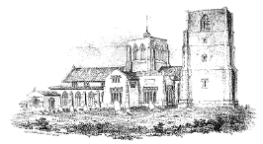
The Friends of
St. Nicholas Church,
Dereham.

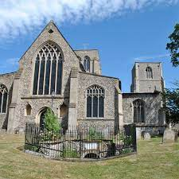

Why Become a Friend?
You will have the satisfaction of making a real contribution to the preservation of the heritage of St. Nicholas Church and of helping to ensure for future generations the presence, security and beauty of this great building.

A Brief History of St Nicholas Church

St. Nicholas (founded 654) is a fine building which is used very flexibly, as much of the furniture in the Chancel and Nave altar area are movable. As well as a place of worship in the centre of the town for over 700 years, the building is an historic landmark and host to many musical and civic events for the community. Extensive internal refurbishment took place in 1980, which has resulted in an attractive and welcoming church, suitable for many forms of worship and liturgy.

The building is central to the town’s population, and the churchyard (closed for all but the interment of cremated remains) is also used as a pedestrian thoroughfare. The church is in good repair and kept warm despite its size. The detached bell tower has a ring of eight bells.

St. Withburga well can be found at the west end of the churchyard, fed by a natural spring.

AIMS
The Friends of St Nicholas Church will be formed to raise funds to ………
- Assist in the repair, conservation and improvement of the fabric and the historically valuable artefacts of this ancient parish church.
- Stimulate interest in the Parish Church.
- Encourage and support activities organized to preserve and beautify the parish Church
- Make financial gifts for the benefit of the Parish Church.

Historically the Parish Churches were built for their communities, and the community helped financially with repair and ministry costs as well as being involved.

We want to see St Nicholas flourish and be at the heart of the community life, which is why we are re-launching the Friends of St Nicholas.

- We have a project in the planning stage that will see toilets fitted, a pastoral room created within the north chapel area where conversations cannot be overheard, a new kitchenette and storage space.

In the future we want to:
- Replace and update our sound system so that it covers all the building and can be controlled from the back of the church.
- Replace our lights with LED equivalent.
- Provide Interpretive panels which tell our story to visitors and tourists.
- Restore the Westminster chimes in the bell tower so they can ring during the day and be silent at night.

We are thankful for good stewards of the building for generally it is in good condition for a building of its age. The congregation do an amazing job of raising £100,000 annually, which covers clergy costs, heating, lighting and insurance and the occasional running repair, but we find it hard to maintain and improve the building as a place for all. There is little left at the end of the year to improve the sound system, the heating and the lighting.

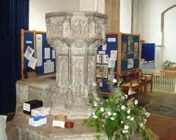
The Font - Made in 1488, it is a ‘Seven Sacrament’ font with the churches sacraments carved on the sides. (Baptism, Confirmation, Holy Communion, Marriage, Confession, Ordination and Unction) The eighth side shows the crucifixion

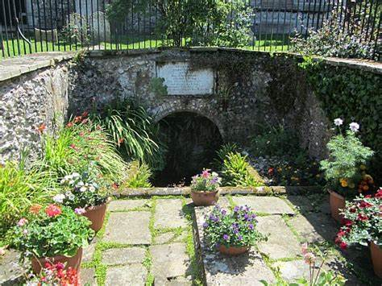
St Withburga Well. Outside the west door is the St Withburga well where the Saint was first buried. It was an important pilgrim shrine in Saxon times. The well sprang up when the remains of St Withburga were removed to Ely Cathedral. A service is held at the well on the first Sunday in July when water from the well is blessed and sprinkled onto the congregation.
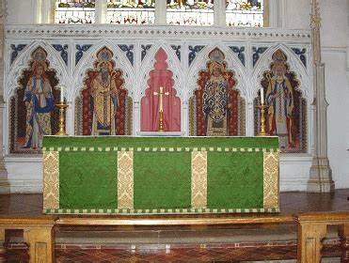
The Chancel - The first impression of the chancel are the views of the East Window (best viewed on a sunny Sunday morning) and the Reredos, the painted screen behind the high altar. The Reredos was made in 1857 and painted to its present condition in 1929. On the south wall of the Chancel is a double piscina (where the priest washed his hands and the sacred vessels during the service) and a stepped sedilia (seats for the clergy).

