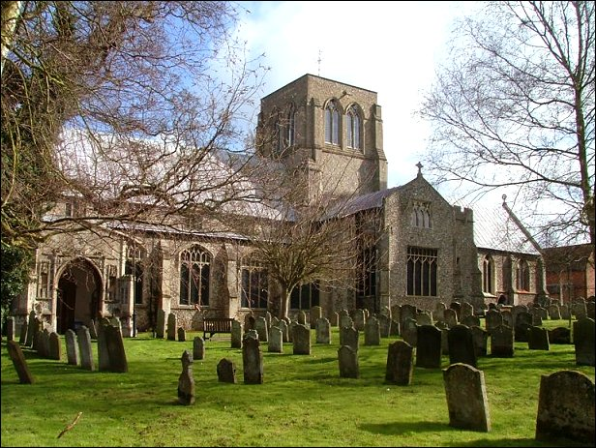

Words from the Well
from Pastor Jacob Rasmussen
We are delighted to reproduce Pastor Jacob Rasmussen’s sermon, based on the first reading of the service on Sunday 3rd June, during the visit to Denmark from some of our Dereham parishioners. Jacob presented Revd Sally Theakston, Gordon and Celia Barker with an English copy which he had translated so that we too could understand his message.
Sally celebrated the communion and Celia read the first lesson Ecclesiastes 5. 10 - 20

‘In the name of the Father, the Son and
the Holy Spirit, Amen.
“Viking Lottery” – Have you seen the television commercials? A bounty beach (Danish expression), crystal clear water, a crisp white sandy beach – and then the speaker talks about what freedom is – to decide if a freshly caught swordfish tastes better on a gas or coal grill! And you see a man in shorts and t-shirt between two big grills! And afterwards, the speaker draws attention to the fact that there are many millions in the lottery next week! Yes, actually there is ninety four million Danish Kroner in the pool on Wednesday!

I do not think I am the only one present today, who once in a while dreams of the big win – playing with the idea of what could be done with nine point four million pounds – I would say at least buy a new bike... and a boat and a sports car and a summer house!

We can dream of winning the lottery – but I do not think that any of us here today lack the big cash, at least not if we compare ourselves with people around the world. For example my good friend Mario from Mozambique, who in Wittenburg, where I met him on a course, had a hard time understanding that chocolate in Germany could cost so much. A single bar was between two and three Euros, when he for ten Euros could buy rice for his family for a month!

But precisely because we are doing so well in Denmark in terms of economics compared to the rest of the world, I believe that a gospel text like today, from Luke’s gospel of the rich man dying just as he is going to enjoy life with his prosperity, unconsciously brings us to the defensive position, because is wealth and prosperity not a bad thing in the eyes of the church?

Often we perceive the church as the guardian of morals, not least in the abundance of wealth – despite the goods and gold of the very same church! Indeed it is an attitude we also hear in today’s passage, where one from the crowd around Jesus asks Him to put his brother in his palace so that the father’s inheritance can be shared – and righteousness achieved.

But if you think that Jesus will quickly swivel up on the high horse of morality and force a division of property through – with social responsibility – then you are wrong! “Who has made me judge or change between you?” Jesus says to him!

Jesus’ parable of the farmer whose wealth is so great that he has to build new barns to have room for everything, only to die before he can enjoy it, is not an indication that the rich farmer should have shared his prosperity – then he would have lived longer. It’s not a hidden threat that money corrupts – though it has a tedious tendency to do so – and that it is finer to be poor in the eyes of God than rich.

Even though we might expect that Jesus puts a moral mark in terms of wealth, that’s not what He does! Jesus does not talk about wealth and prosperity in terms of money – He talks about being rich toward God – and that is something completely different – and for many of us, much more difficult to understand, than if we are
rich or not.
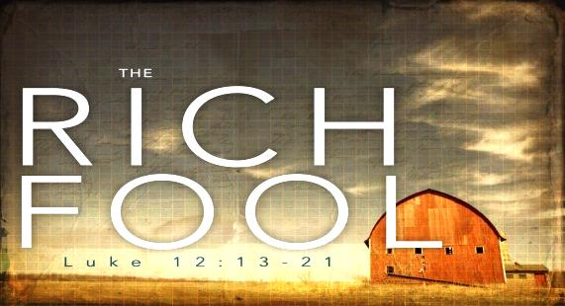
My middle son is eight years old, and is fond of football and weapons! – These “Nerf guns” shoot with foamy cartridges – he’s a ‘real boy’, and yet – when it comes to bedtime, his old teddy bear must be there! It has no name – it does not follow him anywhere – it’s just “monkey” because it is a monkey – and yet he does not close his eyes in the evening without the monkey in his arms.

What should I call it? – is it love? Is that security? Is it friendship? – Maybe it is a mix of everything, I cannot say. What I can say that it is richness for my son! I am in no doubt when I see him lying there with the monkey in his arms.

It makes me ask the question: What is wealth to us – for you, for me? If the answer is difficult to locate, it may be because too much else is allowed to fill our minds – and if we can ‘forget’ what makes our lives rich, how are we able to know the richness we are given from God?

Because we are granted richness from God in our baptism – an unimaginable wealth, which can be boiled down to the words: Love, Grace and Forgiveness. Concepts, which all three of them contain the equality that they are not, something we can deserve!

Who can demand love? – What would it be worth if we demanded to be loved, just as we demand our car to work when it has been serviced?

What would mercy be worth; if we could claim that it should always precede justice! Would it be like writing a blank cheque, so that we could behave as crazily as we would like without a care for other people – and what would Forgiveness be worth, if it could be pulled out of a vending machine, like a pack of chewing gum?!

We acknowledge the richness of God – when we realise that we have the love of God. That we are loved as the person we are, even when everything is falling apart in our lives, and we fail to take control. We face the riches of God when we live on His Mercy – when we dare to trust the word that Jesus Christ died on the cross for the sake of us, so that we could be released to life! We face the riches of God when we let the faith of forgiveness we are donated flow through us and to other people, even though it may be quite undeserved!

We are rich in God if we dare to believe it and act upon it! Unlike the coins in our pocket that become fewer when shared – the wealth of God does not shrink – when we use it to bring joy and peace of mind to our fellow human beings! Imagine if you won the lottery! We do not need to win – because through Jesus Christ we have already won! The question is just how we choose to use the winnings! Amen.

Eric reveals some memories of 1940’s life in South East London
3rd September 1939. I was just 16 and 1 month, and from that day my life changed beyond recognition. My elder brother was called-up to his artillery regiment; my younger brother was privately evacuated to be with Grandma in Blackpool, and I had just commenced an engineering apprenticeship. So here we were: Mum, Dad and myself, facing we knew not what. Dad joined the Civil Defence as a District Warden, while I enrolled into the Red Cross and was quickly posted to a local first aid station in nearby Welling. My works company sent me to college where I studied for the National Certificate in Engineering for one day a week and I also began regular evening classes for Machine Drawing. Weekends took me to fencing classes at the nearby LCC sports ground on Saturdays, followed by Sunday morning church. I had been confirmed during 1938, so I was able to take part in the monthly Holy Communion service.

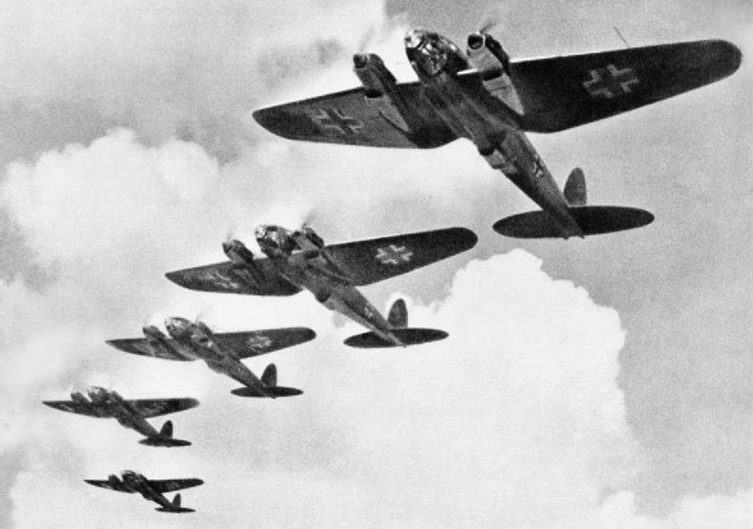

The early summer of 1940 was a scary time, especially if you were living in London. The Blitz rapidly followed the evacuation at Dunkirk and soon the skies of South London were full of dog fights. I remember a particular Saturday afternoon at the Woolwich cinema. The siren sounded around 4pm and we were told to leave the building immediately. As I came out into the street the sky seemed full of menacing planes approaching steadily up the Thames and dropping endless bombs. From that evening the dockland blaze lasted for three days and nights and could be seen for many miles.

In July I became 17 years old and was now able to apply for a driving licence. I volunteered to become a driver in the local Civil Defence unit and so I became involved in ‘light rescue’ work. I qualified as a 1st Aider and progressed to be a patrol leader for my company’s 1st Aid team.

I did get some relief from these responsibilities by using my piano playing skills at local parties. On one such occasion in July 1943 I became smitten with Kathleen. I invited her out, and that was the start of 60 years together; three years of courting and fifty-seven years married.

Very soon after meeting Kathleen I was called up for military service in the Royal Signals and was posted to Bletchley. After arrival my training began in earnest. I had to sign the Official Secret Acts document and was threatened with all kinds of punishments if I disclosed any information about my work. Officially I was supposed to have become a driver, but I didn’t fancy that and was surprisingly allowed to join the Medical Centre team instead.

I stayed at the camp in Bletchley until it closed shortly after the war ended, and was posted to the Command Signals depot in Canterbury where I remained until I finally demobbed in September 1947.

What’s new about a Man’s shed? Colin Gibbard tells us …
‘Men's Shed’ is new to Dereham. Although ‘Men's Shed’ is a national organisation, each local group is independent, totally inclusive, with no religious connections.

Our aim is to combat loneliness and isolation amongst men by providing a meeting place in a safe, informal environment where we can make new friends and offer mutual support, where we can socialise, chat and have the opportunity to work alongside each other. Practical work can be quite varied and up to the members. It may include community projects, making items to sell to raise funds, or simply just working on individual craft or hobby projects. The important thing is that this creates an opportunity for all to learn or pass on skills and benefit socially. We started forming ‘Dereham Men's Shed’ in November 2017, and are in the early stages of development. We are fortunate to have a group of friendly, enthusiastic and multi-talented men and great progress has been made so far. Reactions have been very positive resulting in some members helping each other and sharing skills at other times of the week.
Skills and interests are many and varied. Meetings usually start with a cup of tea/coffee, biscuits and chat, followed by various activities informal or otherwise. These have included demonstrations/talks by members themselves on topics such as woodcarving and whittling (along with the opportunity to have a go). We also learnt more about photography, horticulture, Ireland, painting on glass and had some fun learning a little about the French language. We had an excellent talk on First Aid with a guest speaker from the Red Cross.

Although we do not currently have a workshop available, we hope we will have somewhere suitable shortly. We meet at 2pm on Wednesdays in the Baptist Church, Dereham with the kind permission of the minister Nigel Bayley and the trustees. Come and give us a look - you will be warmly welcomed.

Coincidences …?? Di Lambert
Coincidences happen to everyone I’m sure, but this one from a weekend was amazing. Patrick and I were visiting our younger daughter, Catherine in Herne (near Hern’s Bay, Kent, some 160 miles from home in Dereham).

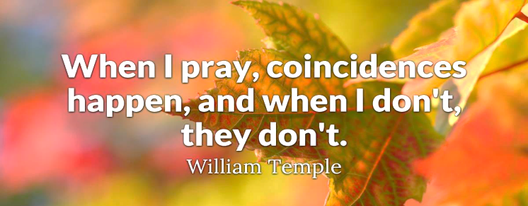

I got up early Sunday morning and walked the 10 minutes to St Martin’s Church for the 8.00am service (the one I frequent at St Nic’s). A gentleman sweeping the church path welcomed me and said he would show me to the right place.

Asking where I was from, I told him, Dereham in Norfolk. ‘Know it’ he said, ‘I have relations living in Gressenhall, and when there a month ago actually went into Dereham on the Sunday Morning to St Nicholas Church to the 8 o’clock service, where the young Curate took the service.’ That was Dominique – and I was there too. How about that??’

An introduction to Margaret Jones

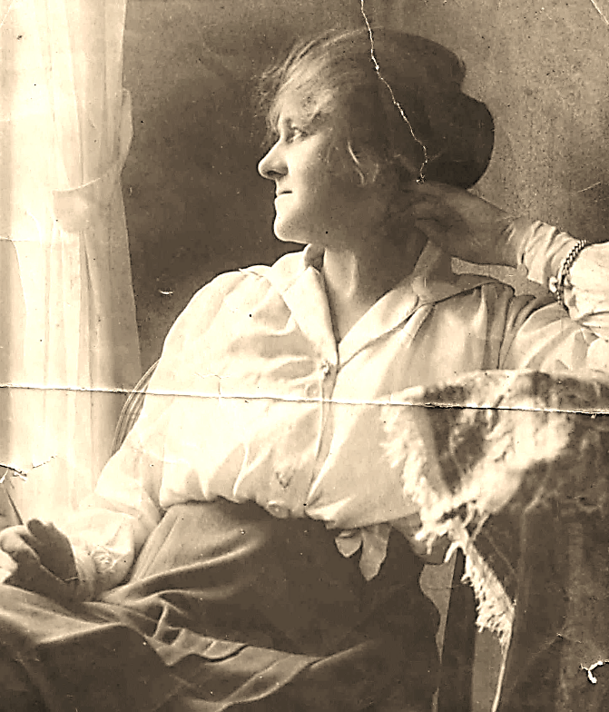

Margaret Jones lived what you might call a fairly typical middle class life by early 20th century standards: she brought up her family and fulfilled the dutiful role of a housewife.

Her grandchildren – me included, although she died when I was very young – realised there was more to it than that. We knew she’d had some sort of connection with the Suffragette movement; but it was only after our Mother died in 2016 that we discovered just how extraordinary that was.
Among Mum’s keepsakes and papers was a newspaper article penned by our Grandma, probably in around 1953, for the newspaper on the south coast that her husband, our Grandpa, edited. It recalled how she was 14 when she was drawn to the “Votes for Women” cause through a chance encounter in a railway station waiting room with none other than Emily Davison, later to become a Suffragette martyr at the 1913 Epsom Derby.

Grandma, born Ellen Margaret Cross, was the daughter of the stationmaster at Knebworth, Hertfordshire, and in due course was befriended by the aristocratic Lady Constance Bulwer-Lytton (“Lady Connie Lytton”), who lived at Knebworth House and who endured multiple terms of imprisonment, self-harming - she scratched the letter “V” for votes into the flesh above her heart with a needle and broken hatpin while incarcerated at Holloway - and force-feeding during the Suffragette campaign.

The schoolgirl Margaret’s contribution to the cause was more modest but no less sincere. And, as you’ll see, the part she played in the Suffragettes’ mission drew detractors as well as admirers – not least the sender of a particularly malevolent Valentine card...

December 14th this year, marks the centenary of women aged over 30 voting in a UK general election for the first time. Here is Margaret’s article: I hope you’ll agree it makes enlightening reading.
Mark Tweedie

Schoolgirl Suffragette by Margaret Jones
I first became a Suffragette when I was a 14 year-old schoolgirl. Although I was too young to take an interest in such things as women’s suffrage when the movement first started, by the time it had become a major national issue I was both old enough and willing enough to do my best to end what I considered an outrageous situation in which men ran the country’s affairs and women had no say whatever.

I was introduced to the crusade – and to me it really was a crusade – when I was sitting doing my homework in a station waiting room. I lived then in a small Hertfordshire village and travelled each day by train from Knebworth, where my father was the stationmaster, to Stevenage to school.

On this particular day, I was hurrying through my homework while waiting for a train home. A woman, well dressed, wearing a large hat, came into the room and began to talk to me. Across her coat, I noticed, she wore a sash of purple, green and white ribbon, the colours of the Suffragettes. Her name, she told me, was Miss Emily Davison. Three years after I met her she lost her life when she fell beneath the King’s horse at Tattenham Corner in the Derby.

I was thrilled, as any schoolgirl would be, to meet a real Suffragette, for these brave women were beginning to make headlines. Miss Davison told me of their work and ideals, while I pumped her with questions. We got on the train together, and on our way to Knebworth she told me she was going to address a meeting there that evening. Filled with the enthusiasm that Miss Davison had awakened in me, I rushed home and told my parents to whom I had been talking. They both strongly disapproved, but eventually they allowed me to go to the meeting that evening.

It was held in the open air, outside the Knebworth station yard. One of the organisers gave me a large bell and I walked up and down the nearby streets, ringing it violently and telling people to come to the meeting. Crowds turned up to hear the speakers, or rather, to shout at them for, needless to say, most of the crowd were very anti-“Votes for Women”; for no better reason, it seemed to me, than “Why should women have the vote?”

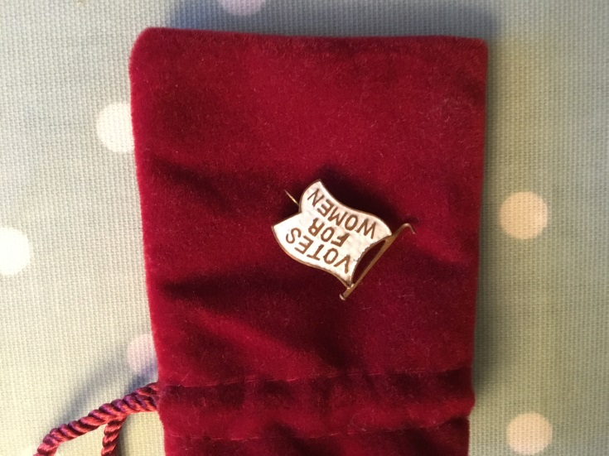

The arguments I heard that evening made the injustices that women suffer burn deeply in my heart. I felt I must, and would, do all in my power to help the cause which I knew was right and just. I began to preach my new gospel to my school friends, and about this time my headmistress herself became interested in the movement. One day, to my delight, she gave us as a subject for composition “Should women have the vote or not?” I wrote my essay with tremendous gusto, and when the headmistress read it she took all the girls into the big schoolroom and read it to the whole school. I, of course, was delighted, although I became something of a butt for the other girls. My success with the essay, however, made me still more enthusiastic – not that politics interested me in the slightest then. All I worried about was the injustice done to women.

My local notoriety as “one of those Suffragettes” must have grown, for soon after this I was invited to tea by Lady Connie Lytton, who lived at Knebworth. She was a great leader of the movement, and told me how pleased she was to meet a young schoolgirl with so deep an interest in women’s suffrage. She gave me a little, flag-shaped, white enamel brooch with the words “Votes for Women” on it in gold letters. I wore it long afterwards with great pride and it is still one of my most treasured possessions. At that time, however, to wear the badge meant almost certain abuse. Women had them snatched off their coats. This never happened to me, but I did suffer some abuse of a particularly cruel kind for my beliefs.

One St Valentine’s Day I received a card, anonymous, of course, which had on it a picture of a Suffragette sitting in a prison cell, wearing a dress heavy with convicts’ arrows. The last lines of the verse ran, I remember, “What man would ever want a wife, who spends in prison half her life?” I never found out who sent it... luckily for him!

Petitions were a favourite way of the Suffragettes to draw attention to their demands, but once the petitioners got inside Palace Yard [Westminster], they were almost invariably arrested. My parents would not, of course, allow me to go to London with any of the petitioners, but I had a friend who was one of the victims. She went with a party of women to present a petition to the House of Commons, knowing full well that she would be arrested. I implored her to let me go with her, but she would not let a schoolgirl take the risk. Inevitably she was arrested and imprisoned, while I was left behind in our village to keep a promise I had made to her before she went: to look after her poultry farm. She came back proudly wearing the little silver prison badge which all members of the movement who had served a sentence for the cause were allowed to wear. It was a model of a prison gate, hung with chains. I longed, with a true martyr’s zeal, to be able to wear one myself one day, but I never did.

Another petition was presented by the famous “Brownies”, a band of women who marched with it from Edinburgh to London. They wore large brown hats, brown coats and skirts, and I was able to join them on part of their long journey. I helped to collect signatures – my own proudly included – for their petition, and I walked with them down the Great North Road from Knebworth to Hatfield. When we got tired, we rested on the banks by the roadside and I ate a large pile of cheese sandwiches which my mother – now, like my father, more or less converted to our cause – had given me.

Soon after the Brownies’ march I was given another Suffragette badge to wear, again by Lady Connie Lytton. This time it was a small shamrock leaf in our colours of purple, green and white. She gave it to me when I went to tea with her a second time, but on this occasion the invitation was to her London flat. There I met, and was slightly overwhelmed by, two of the greatest women in the cause. They were Mrs (later Lady) Pethick-Lawrence and Mrs Drummond – known as “General Drummond” because of her habit of leading demonstrations mounted on a horse. I remember her as a short, stout, commanding woman, telling me how pleased she was to meet so young a member.

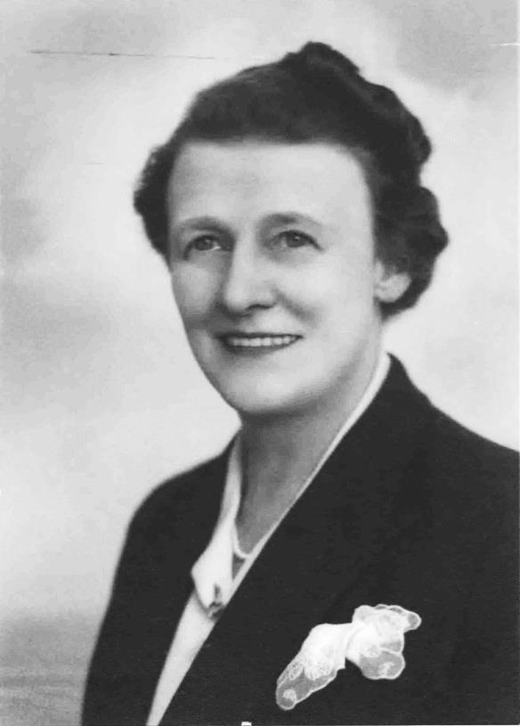
Of course, I had always longed to attend one of the great London rallies, and shortly after this second tea party I had my wish. With what seemed to me to be countless thousands of other women, I marched through London to attend a great demonstration at the [Royal] Albert Hall. General Drummond, on her horse, was at the head of the procession. Each woman carried a small cloth flag in either purple, green or white – mine was purple – and we marched along oblivious to the crowds on the pavements who jeered as we passed. In Trafalgar Square, I remember, I got slightly out of line, and I was hustled back by a man who was helping to marshal the procession. “Keep in line or you’ll be arrested,” he warned me. After that, I kept close to the other women. My enthusiasm for imprisonment waned when the possibility came so near.

In the vastness of the Albert Hall, among all those thousands of other women, I was carried away by the enthusiasm and determination for justice. We waved our “Votes for Women” banners, and clapped and cheered as our leaders repeated our demand for suffrage. I sang, with the rest of that great gathering, the words of our marching song: “Firm in reliance, laugh a defiance.”

The next time I went to the Albert Hall was more than 40 years later, to attend a Women’s Institute conference. I thought then of those great women who had led us on that first occasion and of the years between which had shown how justified they had been in their belief that women must be allowed to play their full part in the affairs of the nation. The song we sung at that second visit was not a militant marching song, but the peaceful words of “Jerusalem”.

The Guild of St Withburga
The Guild of St Withburga was the leading guild in Dereham during the late Middle Ages and had the most imposing chapel. Their feasts, meetings and other ceremonies were held in the Guildhall situated in St Withburga Lane. The guild was dissolved by King Henry V111 during the 1540’s and it is probable that most of the guild’s valuables were taken away to be melted down. The guild owned adjacent lands consisting of 5 tenements plus 20 acres with a rentable value of two shillings and twopence. The land was known as the Headborough lands, all of which were originally for the maintenance of guild members, but from the 1540’s the money began to be used for local upkeep and charities.
It is fascinating to discover that Dereham ‘enjoyed’ many typical medieval features which included a dose of plague in the spring of 1547 when 106 people died. The remnant of the Headborough lands continue to be administered by St Nicholas Church.
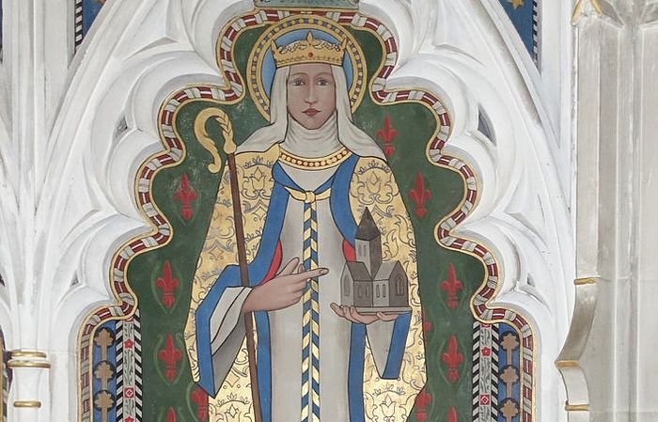

Tea and Tots – what do we do?
… … Marion Morgan tells us
A small but lively group of Mums, Grannies, Aunties, Dads and other carers plus babies and toddlers meet weekly during term time in Church House. The adults chat and drink tea while the children play with the toys and generally create havoc. People share tips on childcare and where to find the best bargains, support those going through tricky moments, and generally enjoy the chance to spend time with each other. We have a prayer, sing nursery rhymes and play instruments, then try to catch bubbles before attempting to put all the toys back in the cupboard in a reasonably tidy way as our little helpers try to get them out again!

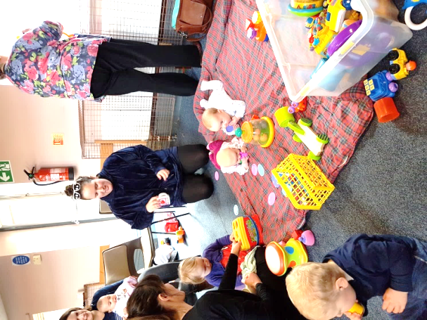
Numbers coming varies, and there is quite a high turn-over as children grow up quickly and go off to Nursery school and so on. Some come for just one or two sessions; others attend for several years as new babies come along in the family. Nearly all those who come hear about it through the Facebook posts which Evelyn sends out regularly, though posters and word of mouth are important too.

The Mother’s Union supports the group and provides most of the adult helpers. If you would like to join the rota of those of us who are ‘young at heart’ and help with an afternoon please do speak to Evelyn Speed or Sheila Hanmer. Whether you help get out and put away toys, make tea or chat, you would be most welcome.

Ann Betts in New Zealand
Since my return from my once in a lifetime holiday last year, several people have been kind enough to express interest in why I went, and how I went, and what memories I have of that fascinating country.

I have always been interested in so-called indigenous peoples; the Native Americans, the Aborigines of Australia and the Maoris of New Zealand. All of them suffered when invaded by Europeans and many still do in various ways; but in New Zealand the Maoris have overcome the early problems and have succeeded in maintaining their own culture while achieving integration with the Europeans.

Meanwhile, various friends had visited that country and all came back with such glowing reports of its beauty and friendliness.

As you will see from the accounts which follow, I spent time with the Maoris, toured the Southern Alps, saw bottle-nosed dolphins, penguins and fur seals, and made some good friends in the process.

Maoris: I have always been fascinated by the native New Zealanders, and very impressed by how well-integrated they are compared with the American ‘Indians’ or the Australian Aborigines. True, there have been wars in the past when white settlers tried to cheat them out of their land, but now they are everywhere, working in hotels, shops and airports with beaming smiles and a great sense of humour.

I was therefore very pleased to hear that our party were to have a whole evening being entertained by the local Maori people of Rotorua.

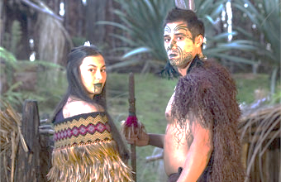

The evening began by our party being collected by a plump, smiling lady Maori driver. As we drove to Waikato we were given lessons in the Maori language and informed that for the purposes of the evening our party was to be a tribe, with its own leader who would be expected to perform certain rituals on our behalf. The venue was a local forest where we were all lined up in front of a clearing. First we heard the splashing of paddles and a large war canoe glided into view rowed by at least ten Maori warriors in full native dress. Meanwhile several maidens also in costume appeared and surrounded the chief. After our leader had performed the peace ritual we were separated into groups and led to different parts of the forest to see demonstrations of Maori weapons, cooking, music and tattooing, not to mention the HAKA!

After the displays, we were all led to a large room where our food was ready. Meat, vegetables and salads, all prepared in Maori style, mainly by steaming. The puddings were delicious Pavlovas. Our evening concluded with a concert of Maori music and beautiful singing.

The Southern Alps and Milford Sound: It is very hard to describe this trip as it is so beautiful. The Southern Alps appear more majestic than those in Europe. We drove through mountain valleys surrounded by the natural vegetation of New Zealand which is still very much as the early settlers must have seen it. It had snowed so hard the previous day that the road had been blocked. Fortunately, it had been cleared for access for us to enjoy pristine mountain scenery in gleaming sunshine. There were lakes, rivers and tumbling waterfalls. I am not ashamed to admit that I had tears in my eyes as I watched view after view, each more stunning than the next. After finally leaving the mountains we reached the Sound; so like a Norwegian fiord where we boarded a boat to sail down to the Tasman Sea. On board we were served with a lunch packed in sturdy cardboard boxes with minimum plastic. After our meal they were collected up to be reused. (English supermarkets please note!)

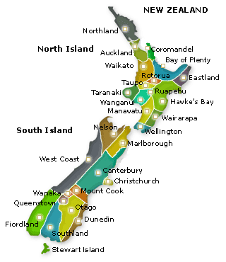

Glow Worms: Imagine being in the dark, with steps barely visible, leading down into an underground cave which seems to stretch far into the blackness. The locals told us that we would begin to see one of New Zealand’s wonders: glow worms. Our guide thought that the difficulties posed by the uneven steps might be too difficult and dangerous for me, but when he saw how disappointed I was he agreed to include me provided I did exactly as he said. This unusual experience began with three flights of steepish steps descending into increasing darkness amid stalactites and unusual rock formations. We could glimpse the occasional spark of light on the ceiling before we reached the boat. I found boarding the craft very difficult, but with the help of several pairs of hands I joined the group again and the boat glided through the dark propelled by an overhead rope. And then they were visible. Thousands of spots of light, covering the ceiling – a truly amazing sight and an unforgettable experience.

Mount Cook: This was the final event of my holiday and was even more special as it was so nearly cancelled. The plan had been to take a flight in a light aircraft over Mount Cook to view the glaciers close up.

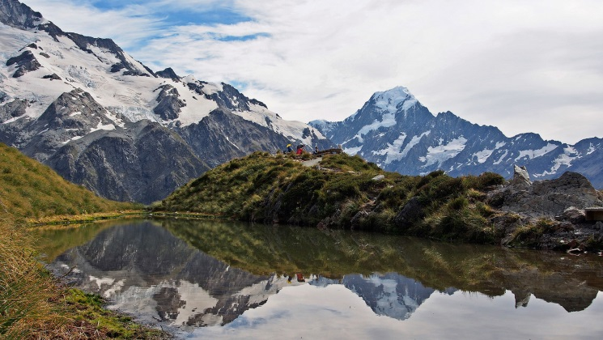

The day we were due to fly was very grey and so no flights. Our leader Brian encouraged us by saying that we could try tomorrow, which would be our last day. When I woke up and looked out the skies were still grey and I abandoned hope of the flight, but when we boarded the coach Brian jumped in and announced that the mist was lifting and the planes were preparing to fly.

There were two planes and I found myself in the larger 12 seater. The snow of two days earlier had improved the appearance of the peaks and glaciers and quite took my breath away. It was a wonderful, amazing climax to the whole holiday. Another experience that I shall never, ever forget.

Ringers make their pilgrimage to Canterbury

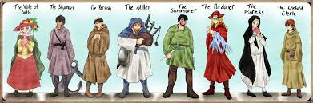

Our thirteen strong party arrived in Canterbury at lunch time on Monday 26th June. While Celia and Chris were parking the mini-bus in the Cathedral precincts the rest of the party found a shady picnic site in the Dane John Park close to the city wall. After lunch, several members ascended the steep path of the 9th century mound to the significant war memorial. Following the pilgrim’s path the group walked along the wall via the main city thoroughfare and through the lane leading to Christ Gate. We then continued to our river trip meeting point on Stour Bridge. Everyone enjoyed the tranquil experience, gliding through clear cool water in the hot sunshine. We passed numerous ancient buildings, formerly centres for the Benedictine, Dominican and Greyfriars communities. We were staying at the Cathedral Lodge situated within the precincts, with great views of the cathedral just a few yards away.

Our party were given excellent seats in the Choir for Choral Evensong where we were warmly welcomed by the Dean. Many members found the service a revelatory experience. Quite a few pairs of eyes widened when the opening notes of the responses were sung. The service contained Tudor canticle settings by Thomas Weelkes, while the glorious anthem ‘Call of Wisdom’ which was written for the Queen’s Golden Jubilee by Will Todd in 2012. After the service, several of us had the opportunity to meet the Dereham representative in the choir; David Wilcock with his wife, who is expecting a baby very shortly.

Our evening ringing took place at the lovely St Stephen’s Parish Church with its glorious 8 bells.
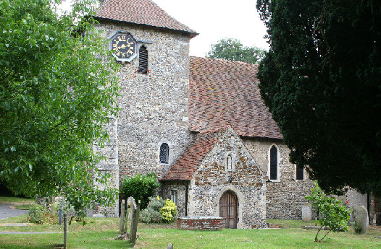

We were given a very warm welcome and during the ringing Jaden upheld the honour of Norfolk ringers with a faultless touch of Bob Doubles on the treble bell. Our evening continued with a fine meal at ‘The Old Beverlie’ pub, just a few yards up the road before returning to the Lodge.

A hearty breakfast prepared us for our cathedral tour. We met with John our guide at the Welcome centre and made our way through the South Porch and into the immense nave. After a short introduction John led us along the pilgrim route under steps leading to the Screen to the site of Becket’s murder and subsequent martyrdom in the North Transept.

Starting in the Crypt and through the Choir, a steadily rising route took us upwards past the High Altar and into the Trinity Chapel which appears to stretch even further forward into the ultimate corona. We saw the distinctive marks made by the knees of countless pilgrims surrounding the site of the great shrine, and we also took in the royal tombs of Henry1V and his Queen Joanna as well as the famous Black Prince. Fortunately we had time to appreciate the spectacular medieval glass, especially the ‘Miracle’ windows dating from the early 13thC.

After a welcome coffee stop we said farewell to England’s Mother Church to move onward to Chalkpit Farm for a Mama Feelgood lunch, before a final 6 bell ring at Bekesbourne village church and a reluctant journey home.

The 38 most important days of the year - from Revd Jenny Taylor
What a long season we have for Easter! By the 6th or 7th Sunday of Easter, the Easter eggs have all been eaten and long forgotten. Why is it such a long season? Why do we keep 38 days ie: more than a month in our Churches year between Easter Sunday and Ascension Day?

I am going to tell you that those 38 days are the most important days in our Christian year. Even more important than Christmas Day, Easter Day and Pentecost. Now that is a pretty bold statement, so why do I say it?

To find out, we need to take a walk around our town. So come on! Jackets on!
Off we go … … … … …

We are heading down Church Street, and into the Market Square, to look at the Cowper Memorial Church. Oh! What a shock. It isn’t there. There is a sports shop there. Lovely trainers!

Oh well, we will go down the High Street. The Baptist Church is there. Oh dear! Whatever has happened?

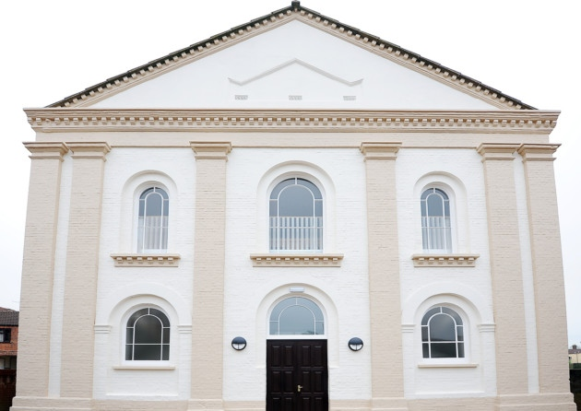

There is a posh hotel there. This is strange. Let us wander on to the Roman Catholic Church. Surely that will still be there. Oh No! IT’s a block of flats. Well people do need homes, but surely they need churches too.
Up the road we go to the Wellspring Family Church, right by the railway line. Oops, it’s a Bike Shop, This is crazy, but we go along the road and turn right up Nicholas Street. The Salvation Army is there. That must be there, after all. They are all over the world, aren’t they. No … I don’t believe this!! What are those bright lights? Oh, it’s a Night Club.

Wearily we trudge along to Trinity Methodist Church, only to discover that it’s a car sales place. Oh dear!

Let us return to St Nicholas church. At least we know for sure that that is there.
In the market place we meet a policeman, so we ask him, ‘Where have all the churches gone? What has happened to them?’

We are stunned by his reply. ‘Churches? What do they sell? No, we have never had any of those here.’ Puzzled, we ask him again and impatiently he replies, ‘Look here, I told you, we don’t have any. I’ve never even seen one in Norwich.!’

But there is a big building. What is that sign on it in Big letters? LALA BINGO! Oh, well that is fun, but where is our church?

Now, you think that this is rather silly, but in fact if it weren’t for those 38 days, that is a examples of what our lovely town would be like.

Sadly we start to retrace our steps up Church Street, but we notice that it’s no longer called Church Street. The sign says, Withburga Street. At last we can get back into our own beloved church, but as we look down the street, there is no Bell Tower.

Why? Just think even if only Mary Magdalene had never seen the risen Christ, people would have thought she had gone somewhat mental. If only the two disciples that found the empty tomb and met the Risen Lord Jesus on Easter Day, people would have said that they were imagining things.

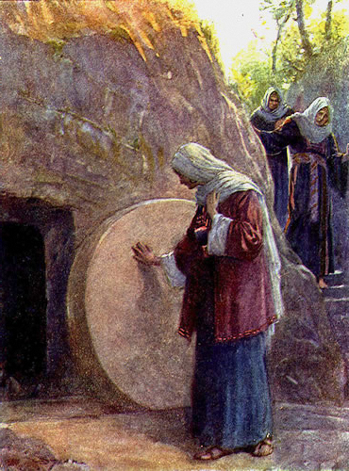

Even is all the disciples to whom Jesus appeared on Easter Day, had told others, people would say that it was wishful thinking or that they were being dishonest.

But the fact is that for a further 38 days Jesus appeared, not just to the disciples, but to hundreds of people. He walked, and talked, and ate with them. There were so many eye witnesses that the fact of his Resurrection could not be doubted.

38 days

How gracious Jesus is. Not only did he die for us and rise again, He lovingly waited for another 38 days before going to his home in heaven, in order that you and I and all people can believe without any doubt that He is risen in deed . Alleluia!

If He had not done so, Jesus would soon have been forgotten. There would be no church, no New Testament, no hymns, no Baptisms, no Church weddings or funerals, no peace with God. No Salvation, No Christmas, No Easter, and so I could go on.

But Alleluia, Jesus Christ is Risen and Alive with us today. Amen.

From the Editors
A big thank you to all our contributors for this very special edition. We were very pleased to receive considerably more material this time. The closing date for Winter edition material is Monday 8th October and we look forward to receiving more interesting content from you all.
Send at any time to ceegebarker@ waitrose.com

